**Install Splunk Forwarders**

Source file:

G:\OPS\Software\Splunk\Software\Universal Forwarder\Universal Forwarder - 64 bit Version

splunkforwarder-6.6.0-1c4f3bbe1aea-x64-release.msi (latest install, could change later)

By UNC, Copy from G: drive to destination’s C: drive

Double-click to run installation

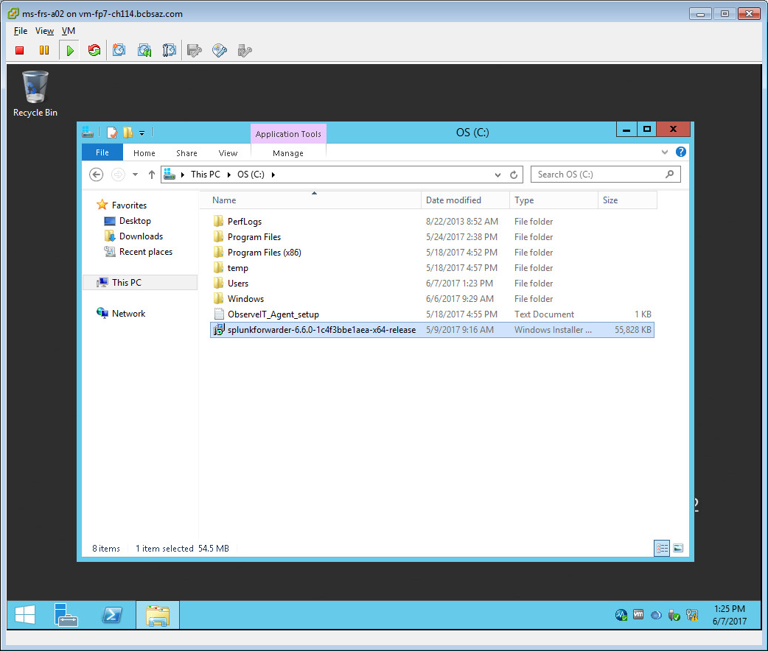

Click on run

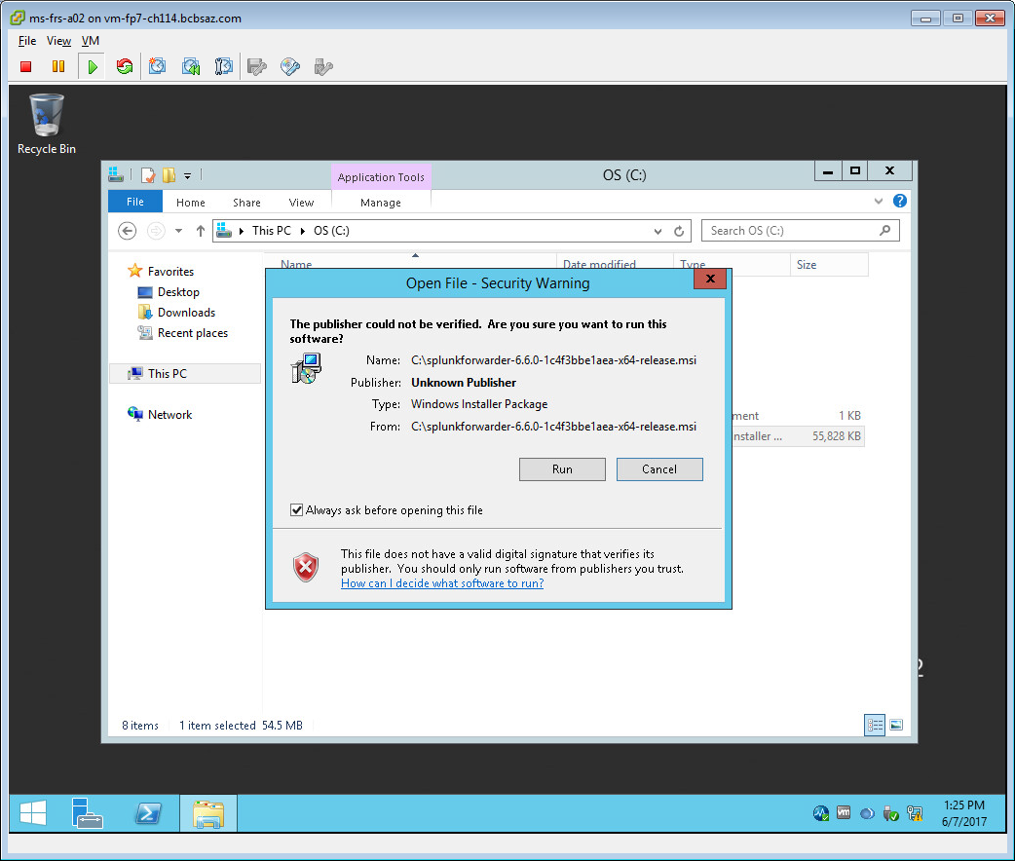

Check mark **Check this box to accept the license agreement**

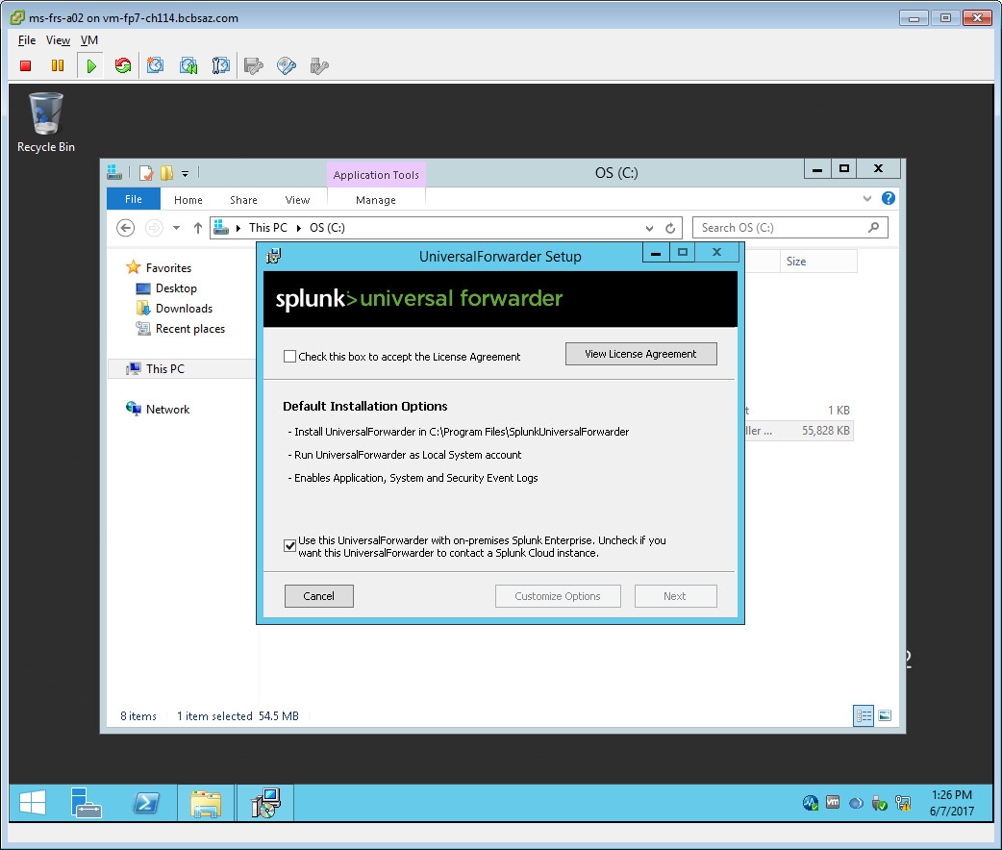

Then click on **customize options**

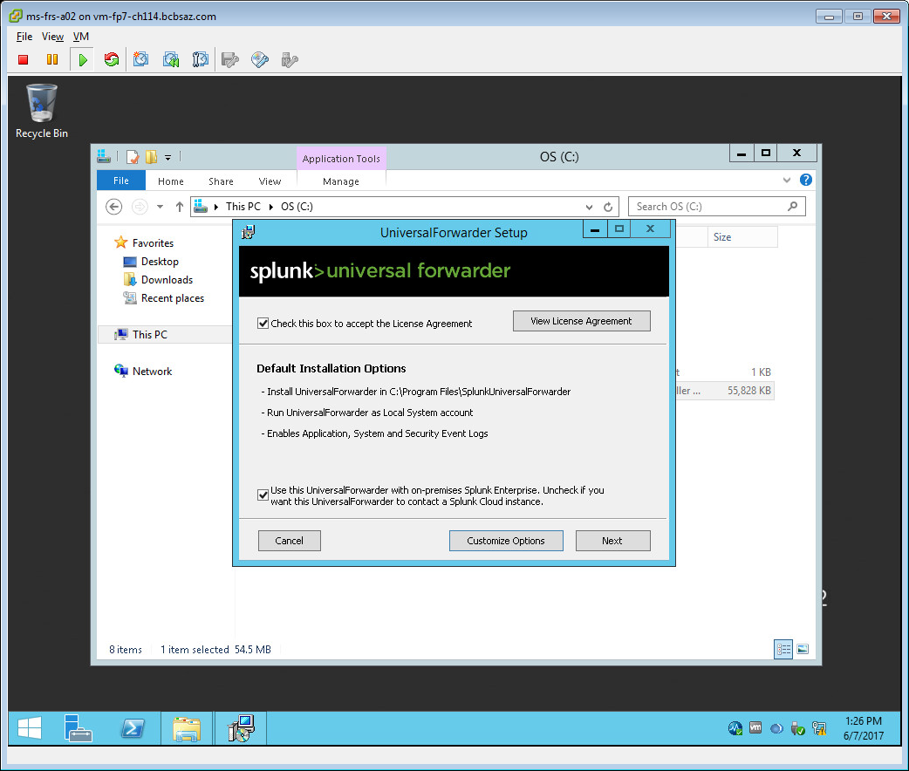

Change from C: drive to **D:** drive

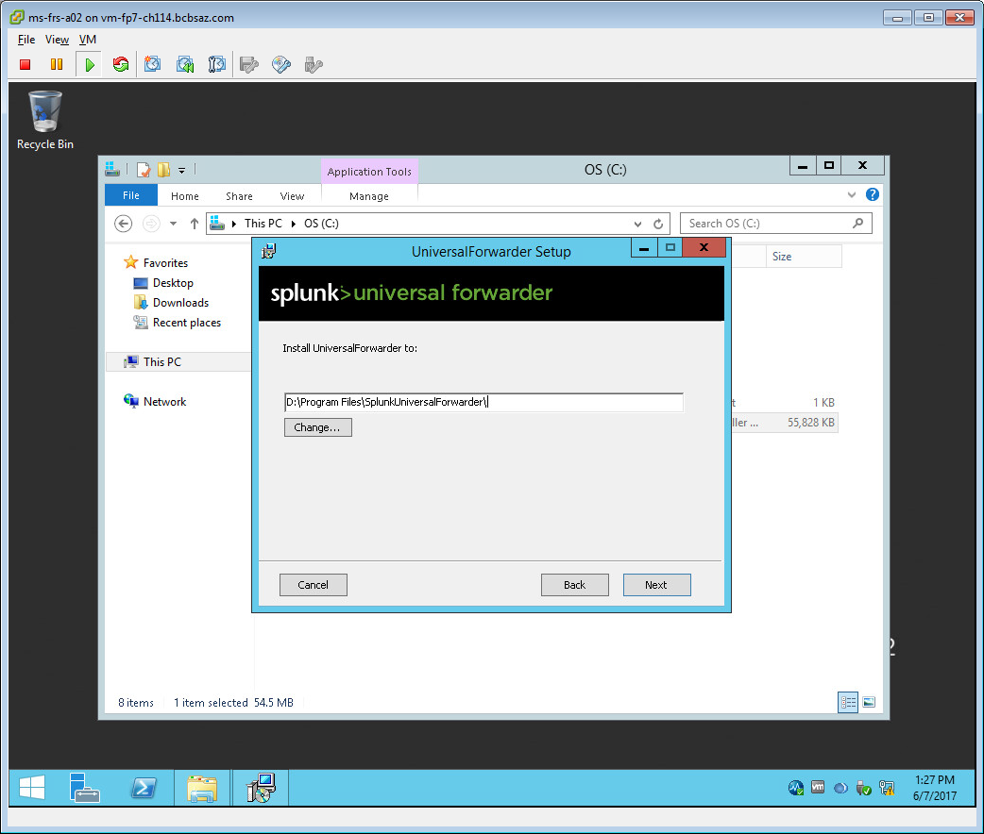

Leave as is

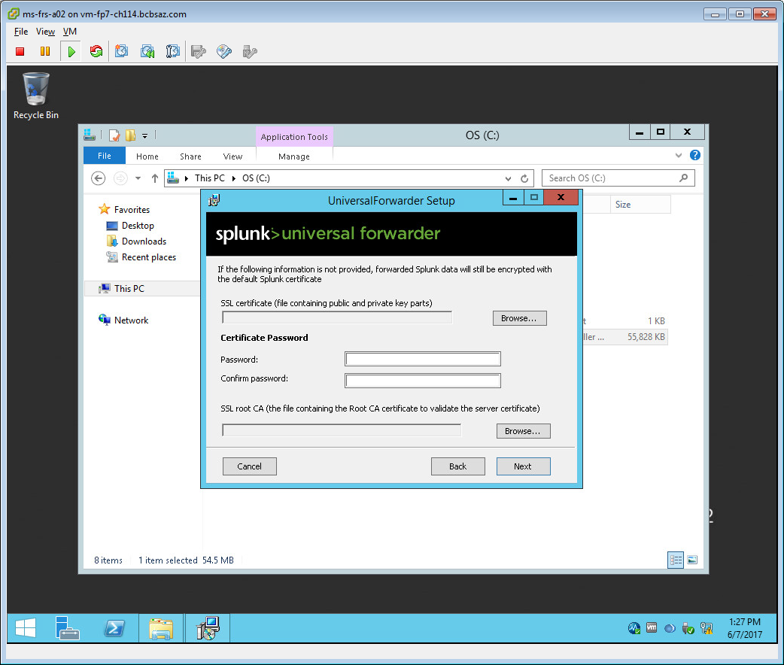

Select **Local System**

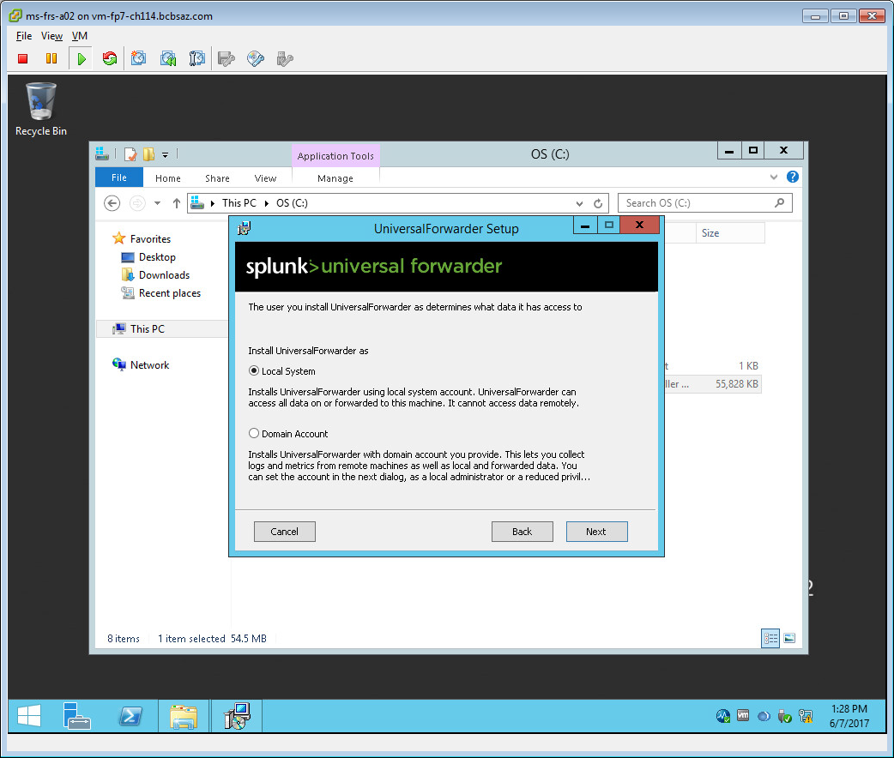

Leave as is

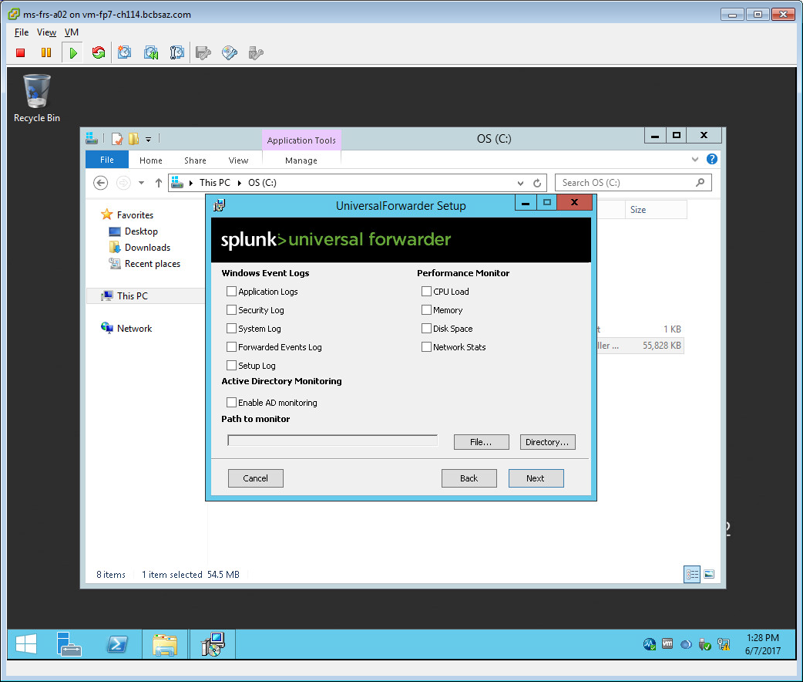

Add the user name : **LP-spl-a06.corp.net.bcbsaz.com**

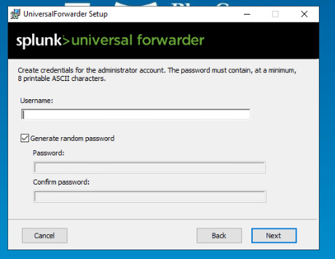

Password: see login

Enter hostname or IP as LM-SPL-A06.corp.net.bcbsaz.com (deployment server)

**LP-spl-a09.corp.net.bcbsaz.com - OLD**

Enter Splunk Management Port as **8089 asstastic**

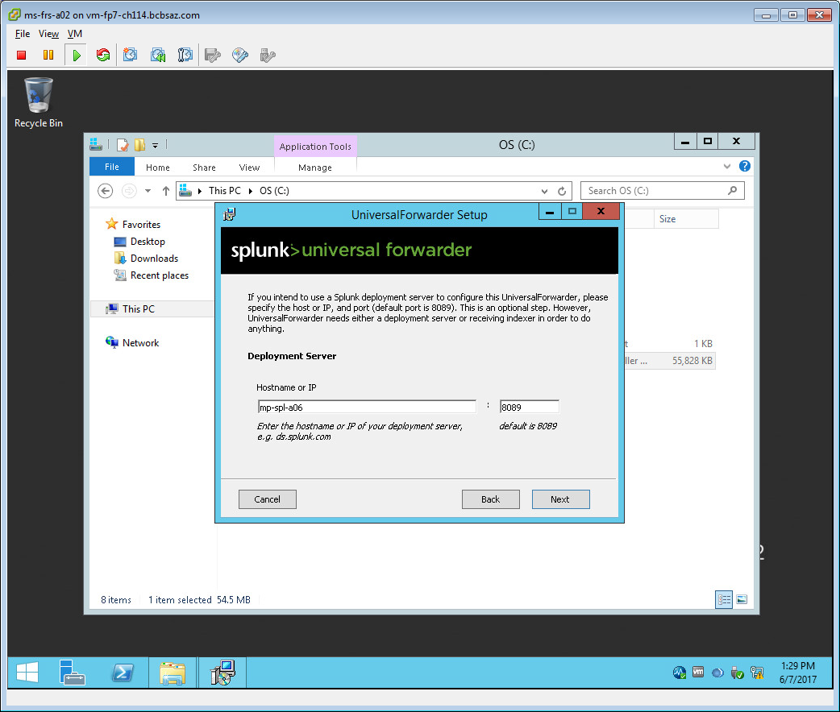

Leave as is

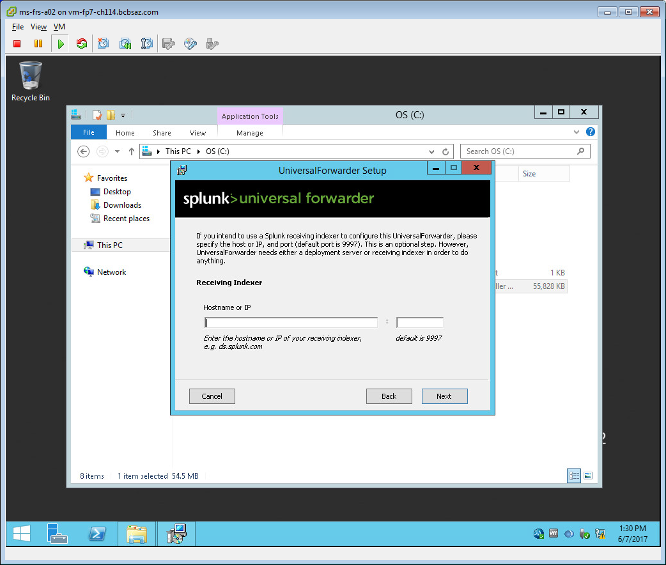

Click **Install!**

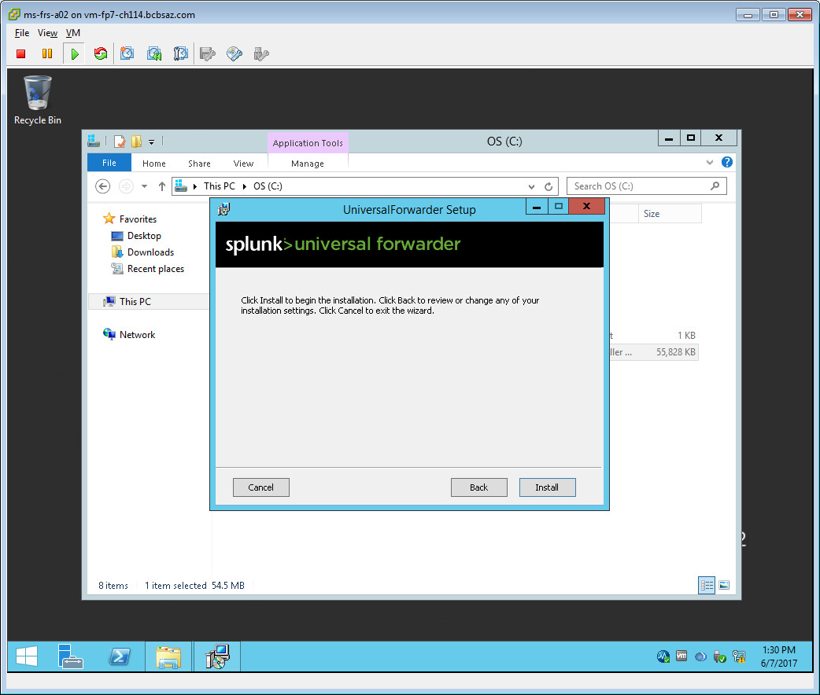

Installing… wait!

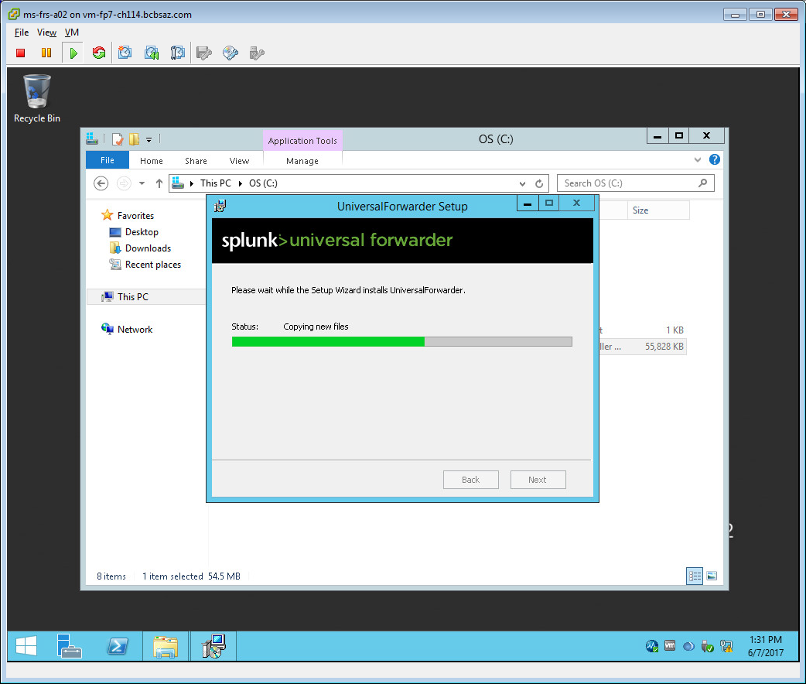

Last screen will pop up, click **Finish**

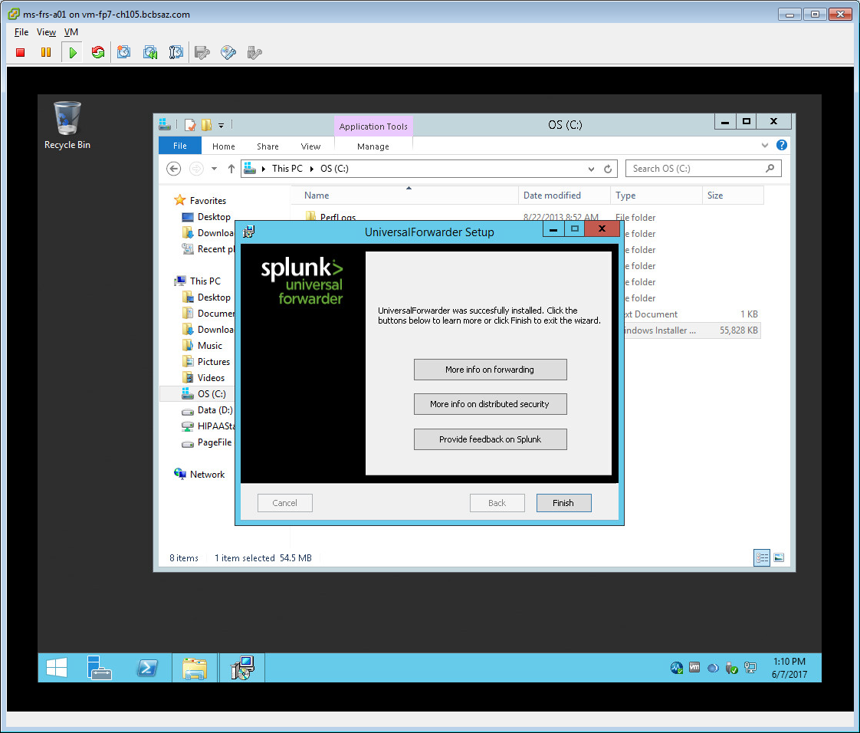

To confirm installation, make sure **Splunkforwarder service** is running

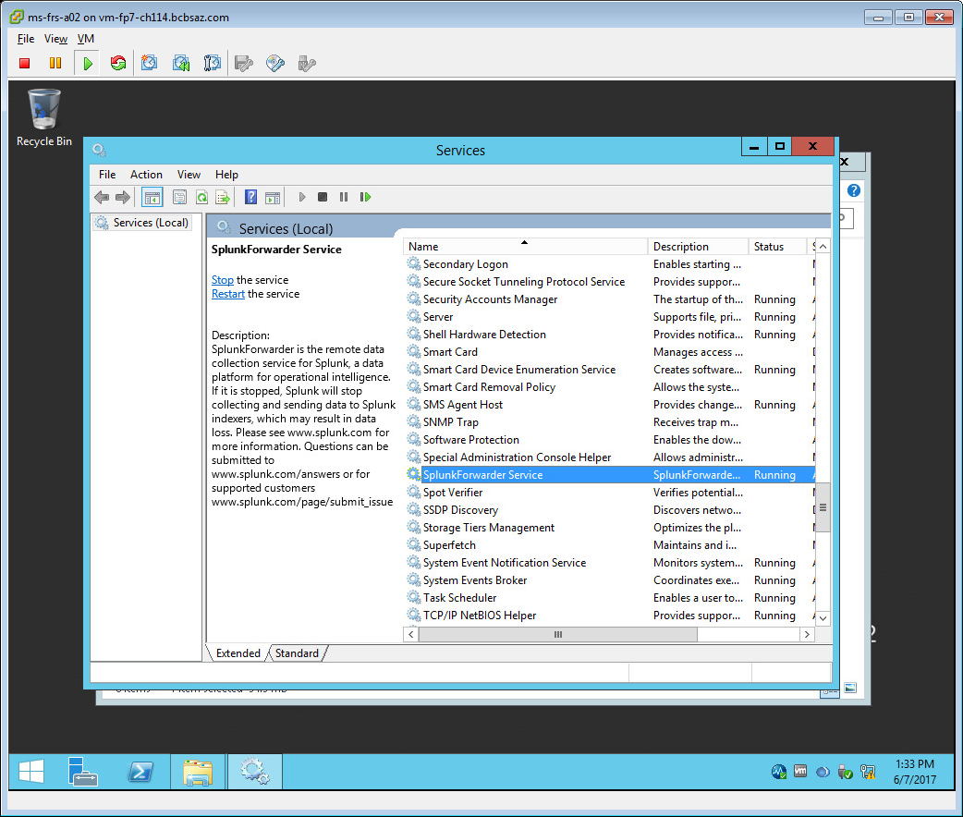

Next Page…

FYI:

I installed spunk forwarders on servers: ms-frs-a01, ms-frs-a02 and ms-frs-a03

If you log into splunk dashboard (mp-spl-a09)

Type **index=* host="ms-frs-a*"**

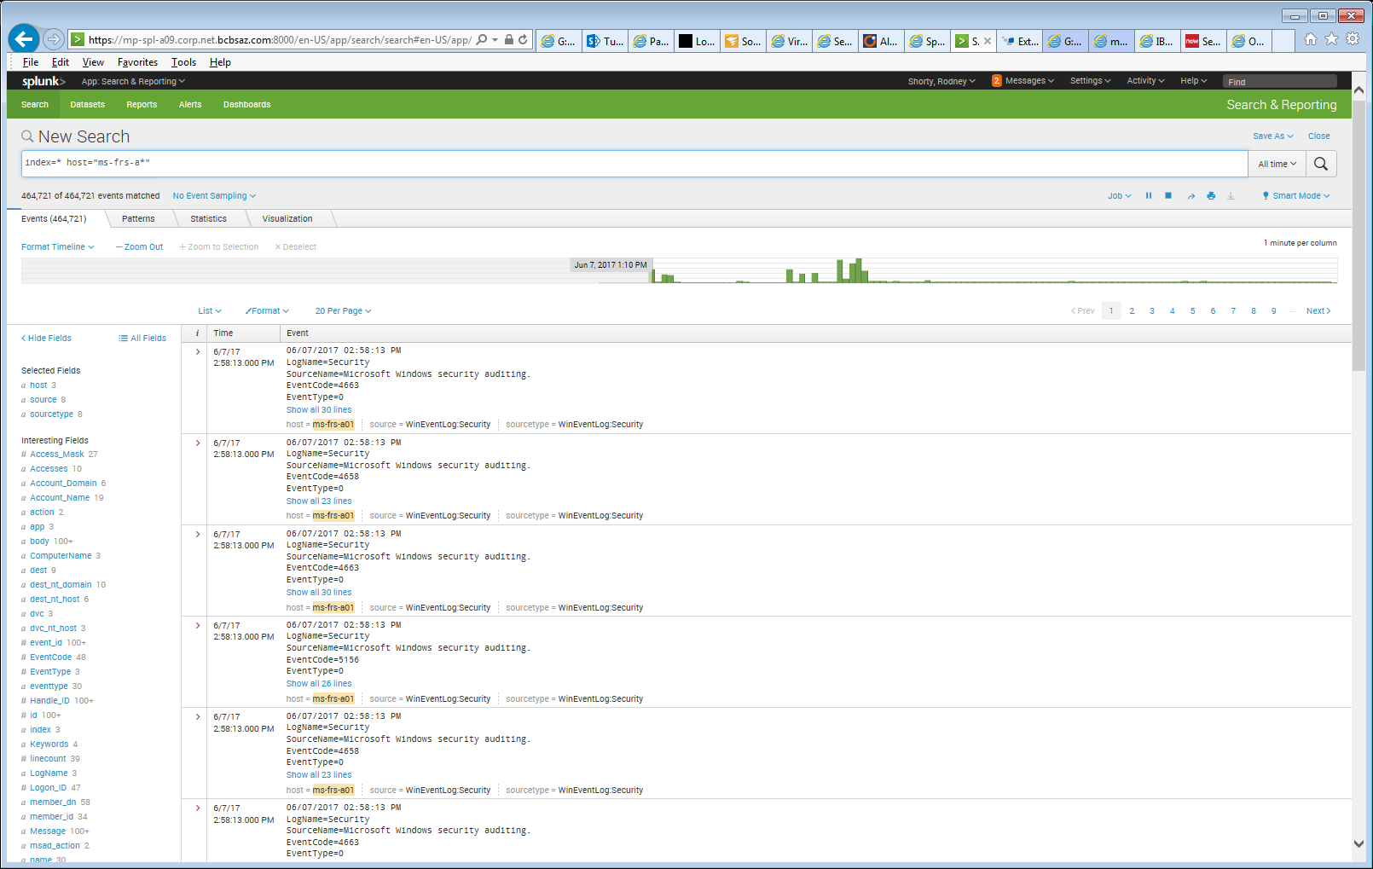

If data is return then it is working!